**Project Proposal**

**Software Engineering**

CSE327

Section: 6

**Faculty:** Sarnali Basak (SLB)

**Submission Date:** 1st March 2023

**Group Information:**

Group Members:

|  |  |
| --- | --- |
| Member Name | ID Number |
| Md. Nafiz Al Mahmud | 2012241042 |
| Asif Rahman | 2012691042 |
| Mia Mahmudul Hoque Shaon | 2014314042 |
| MD Nazmul Islam Srabon | 2021227042 |

**Introduction:**

Our project is a web-based E-learning platform called জীবন যুদ্ধ. It is designed to meet the needs of educational institutions, teachers, and students alike. Whether you are a teacher, or a student, our platform offers a range of features to streamline the management and learning process.

There are three types of users: Admin, Teacher, and Student.

For teachers, our website provides tools for creating and organizing courses, and managing assignments and assessments. Teachers can easily track student enrollment.

Students benefit from a user-friendly interface where they can access their course materials and assignments. Our website fosters a dynamic and interactive learning environment, enabling students to engage with course content and enhance their educational experience.

Admin have access to a comprehensive users list, allowing them to monitor the enrollment of students and the creation of courses of teachers.

**Vision Statement:**

জীবন যুদ্ধ is an online web application for students and teachers who want a simple but effective education platform. Unlike currently available platforms, জীবন যুদ্ধ is a free platform. It will provide a simple, intuitive interface that will also make sure that the teachers are verified and make study much more comfortable.

**Features:**

**Student:**

* Registration and login
* Enroll and Drop
* Edit profile

**Teacher:**

* Registration and login
* Upload course material
* View Course list
* View all Student of their respective course
* Remove a particular student from a course
* Edit Profile

**Admin:**

* Login
* Verify teachers (reject/accept)
* Remove user (teacher, student)
* Remove Course
* Manage the whole system

**Major Functional Requirements:**

1. Students must register to enroll
2. Teachers must complete the verification process to register
3. The student must be able to search for courses
4. The system must allow the students to see the teacher’s profile.
5. Teachers should be able to publish their course materials
6. The system must allow the admin to remove students and teachers account. Also irrelevant courses.

**Non-Functional Requirements:**

1. The users can request to remember their passwords.
2. Forgetful users can reset their password.
3. The website will keep track of the total number of teachers, students and courses. Also, display the count in the homepage.
4. Students can also search for courses by category from their respective profile page.

**Diagrams:**

**1. Use Case Diagram:**

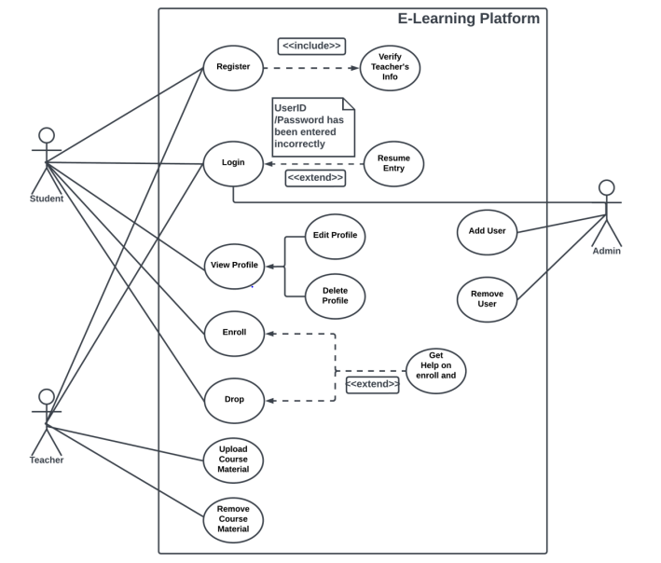

**2. UML Diagram:**

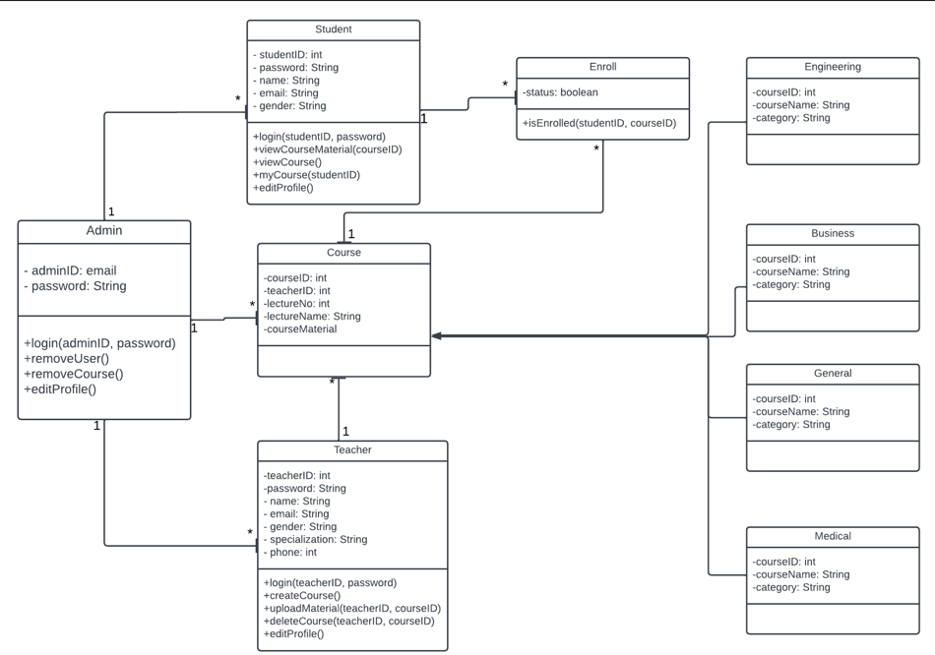

**3. Sequence Diagram:**

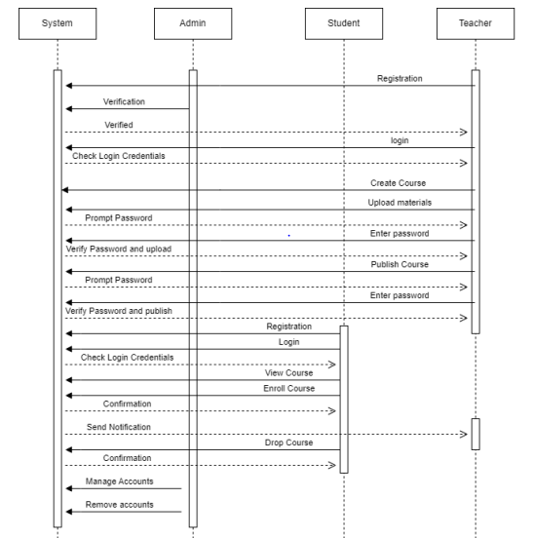

**Use Cases:**

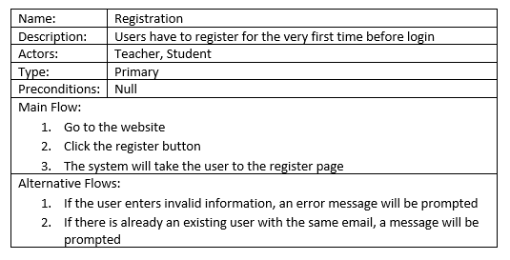

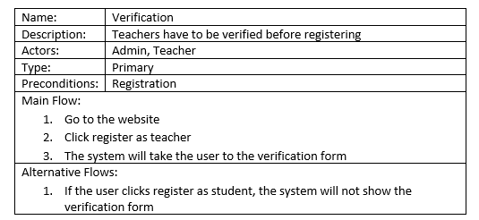

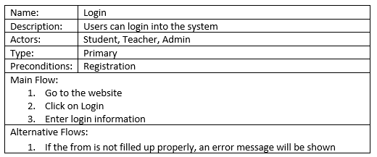

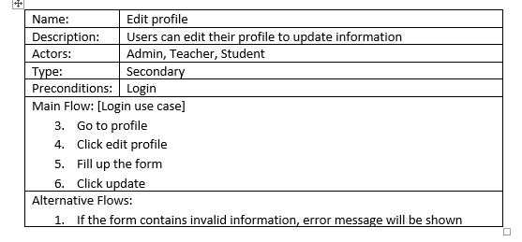

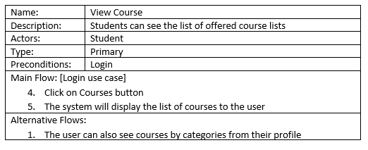

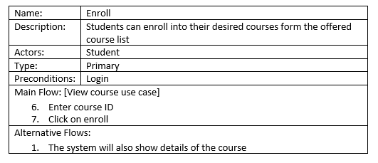

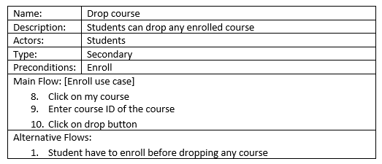

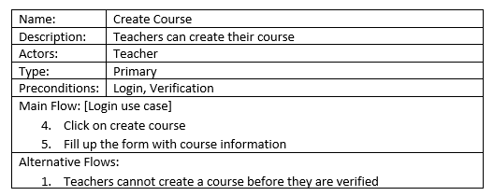

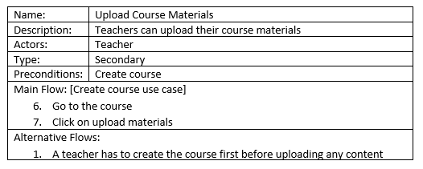

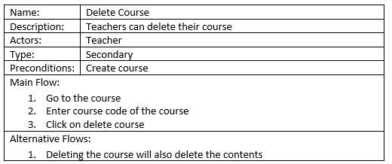

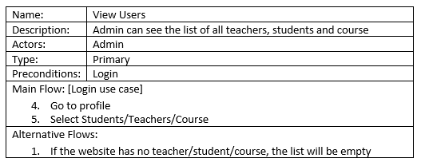

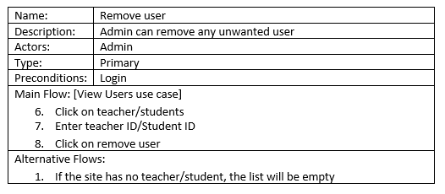

**Implementation:**

1. **Database**

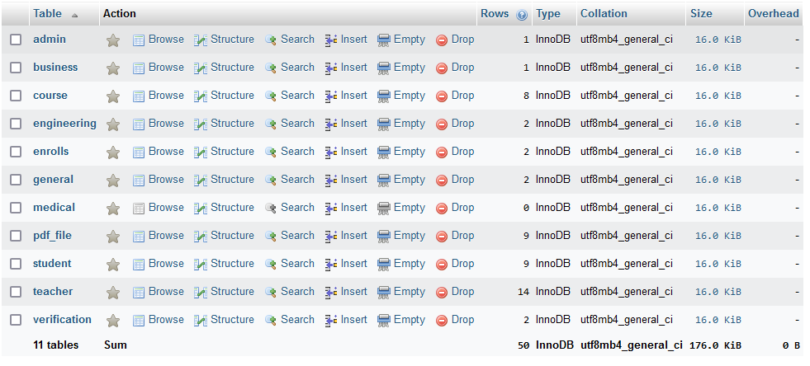

1. **Interface**



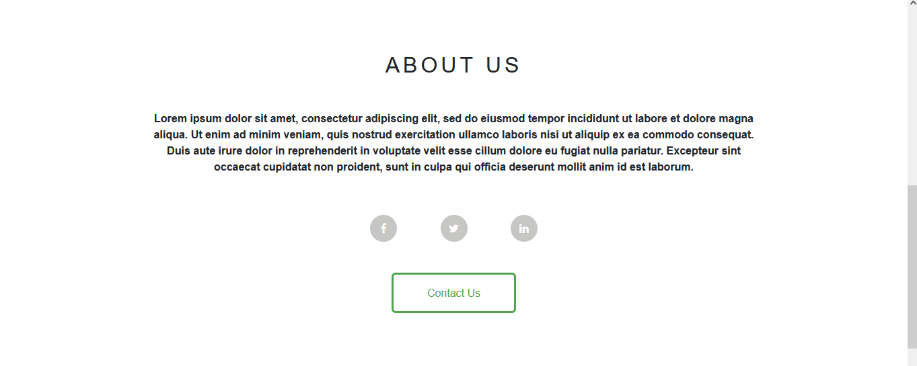

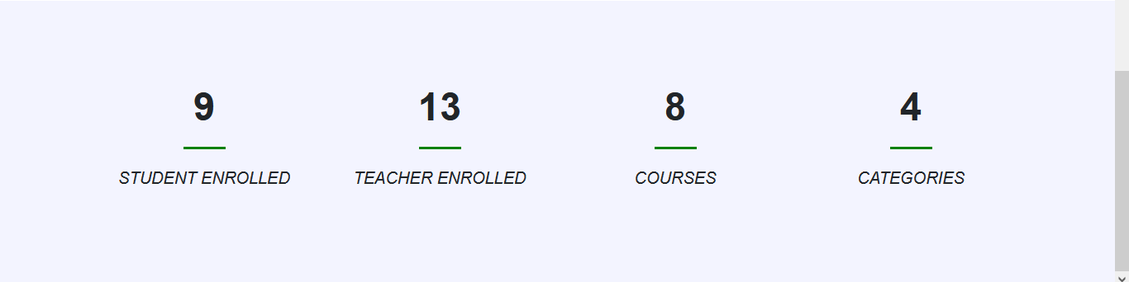

**Home Page**

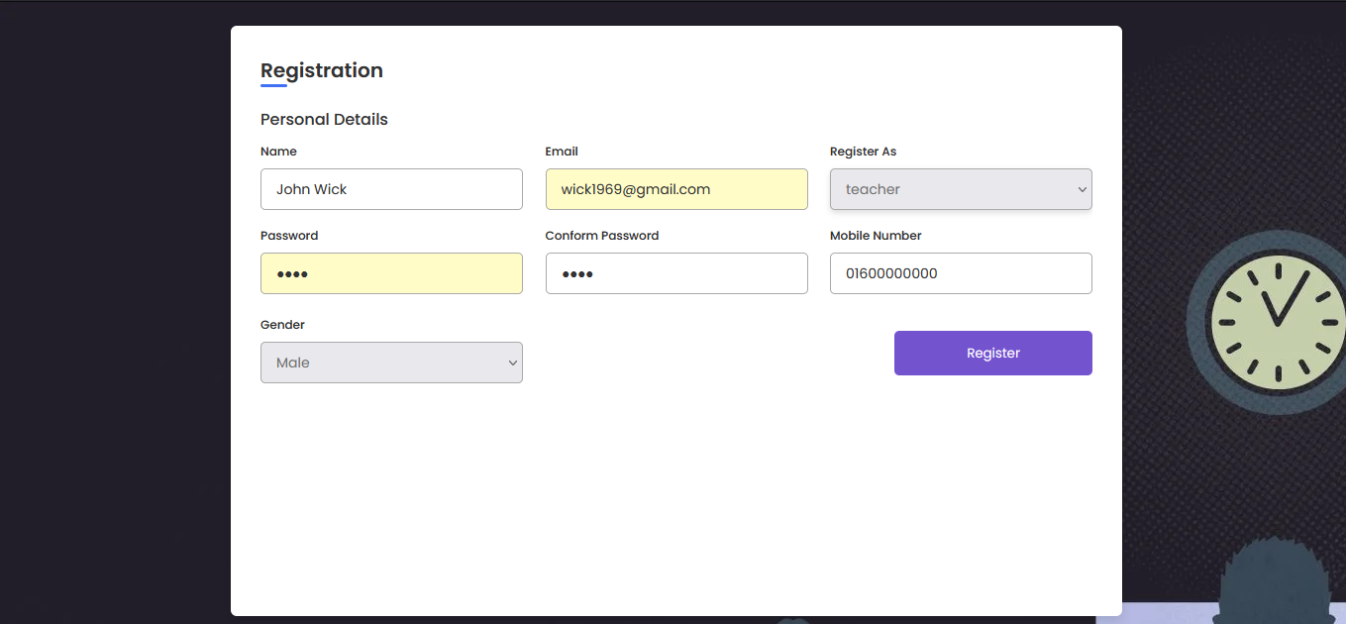

**Registration Page**

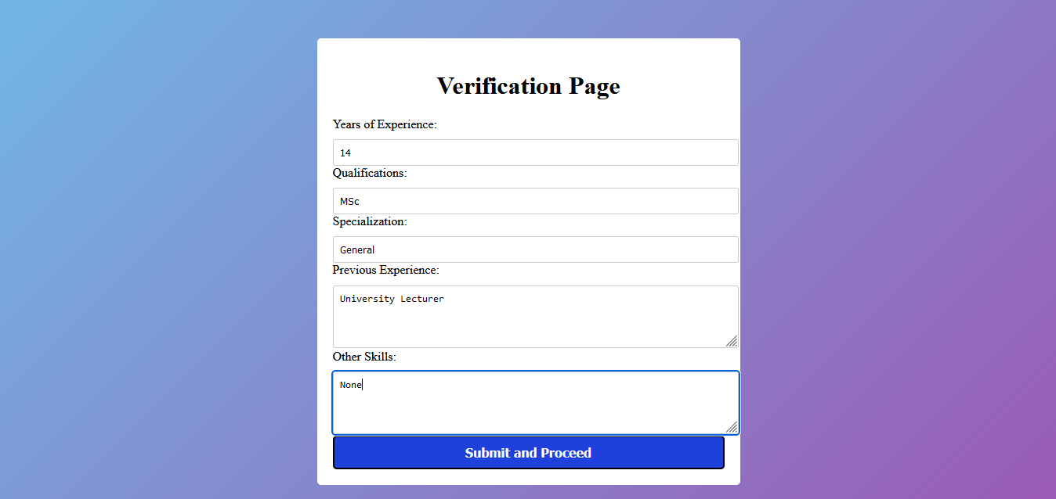

**Teacher’s Verification Page**

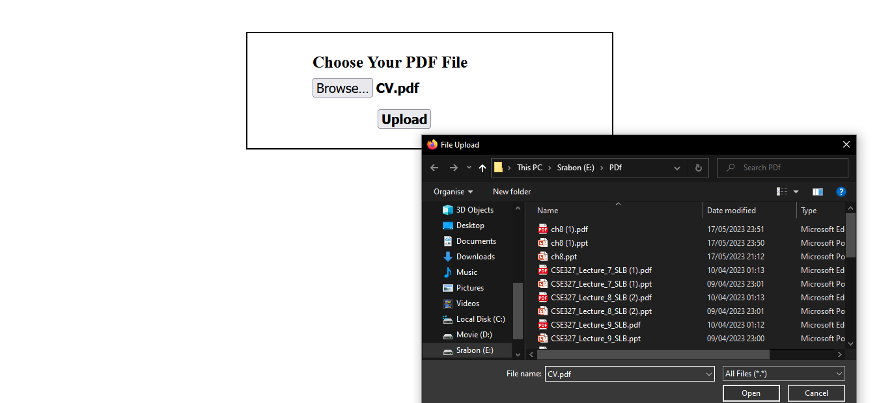

**Upload Teacher’s Verification Document**

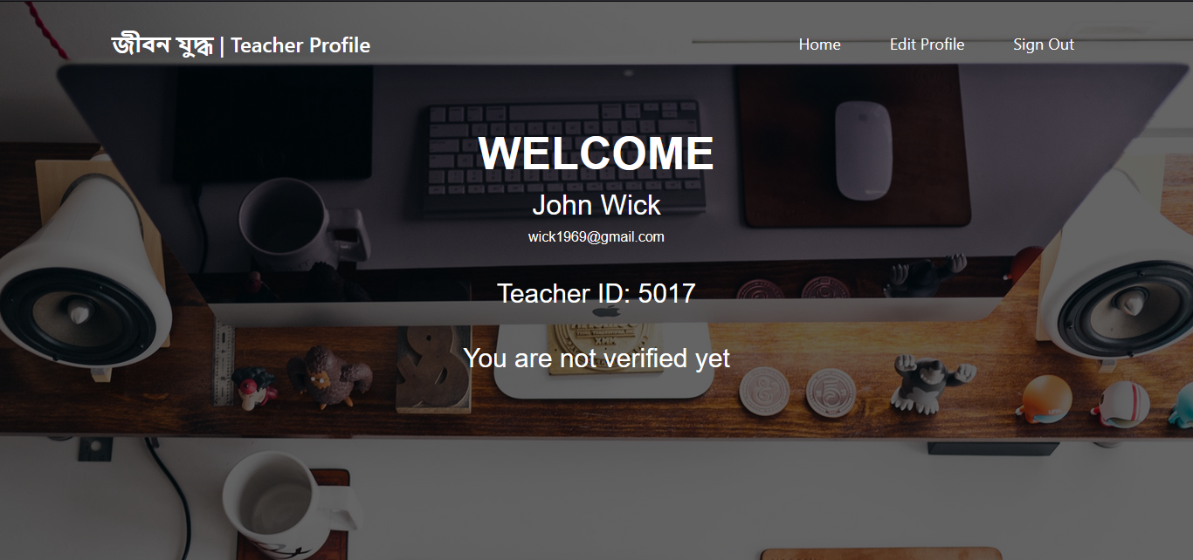

**Teacher’s Profile (pre-verification)**

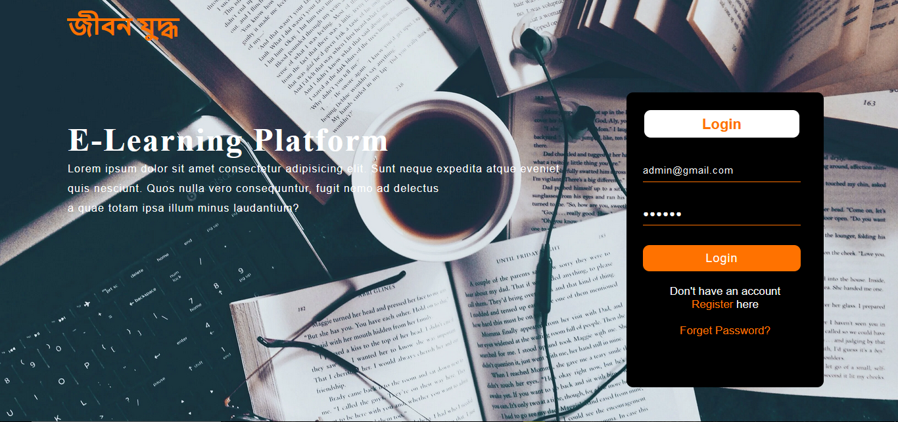

**Login Page, for all users**



**Admin Profile**

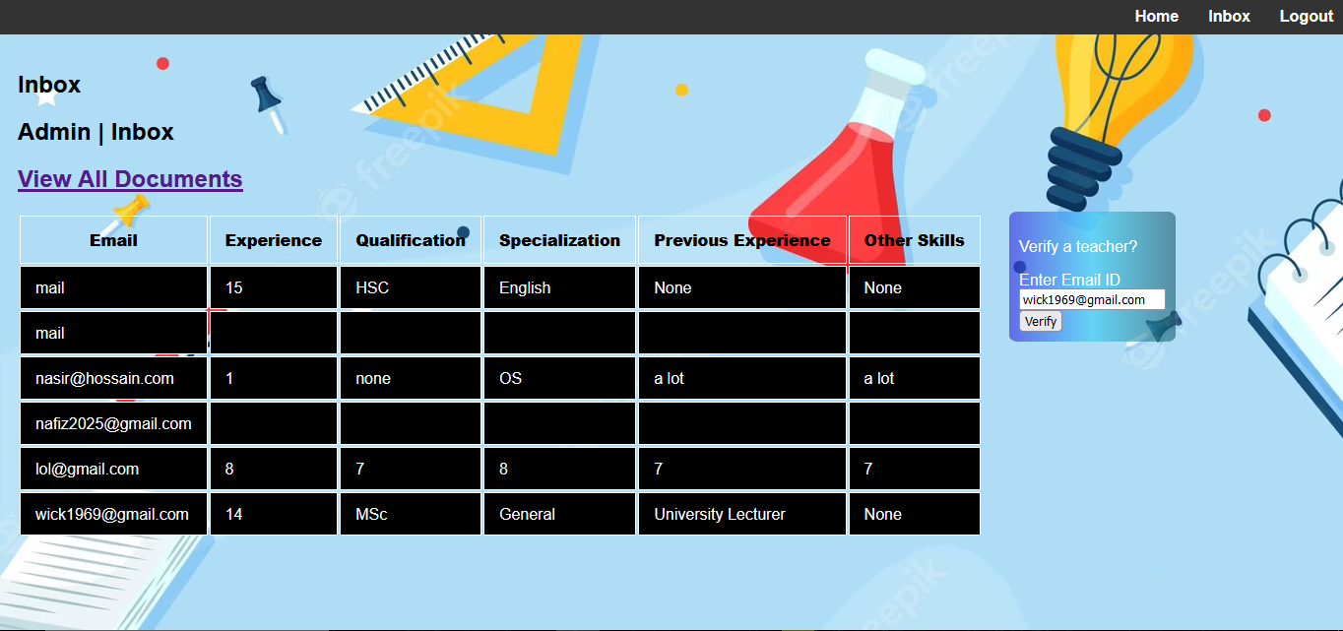

**Admin inbox (before)**

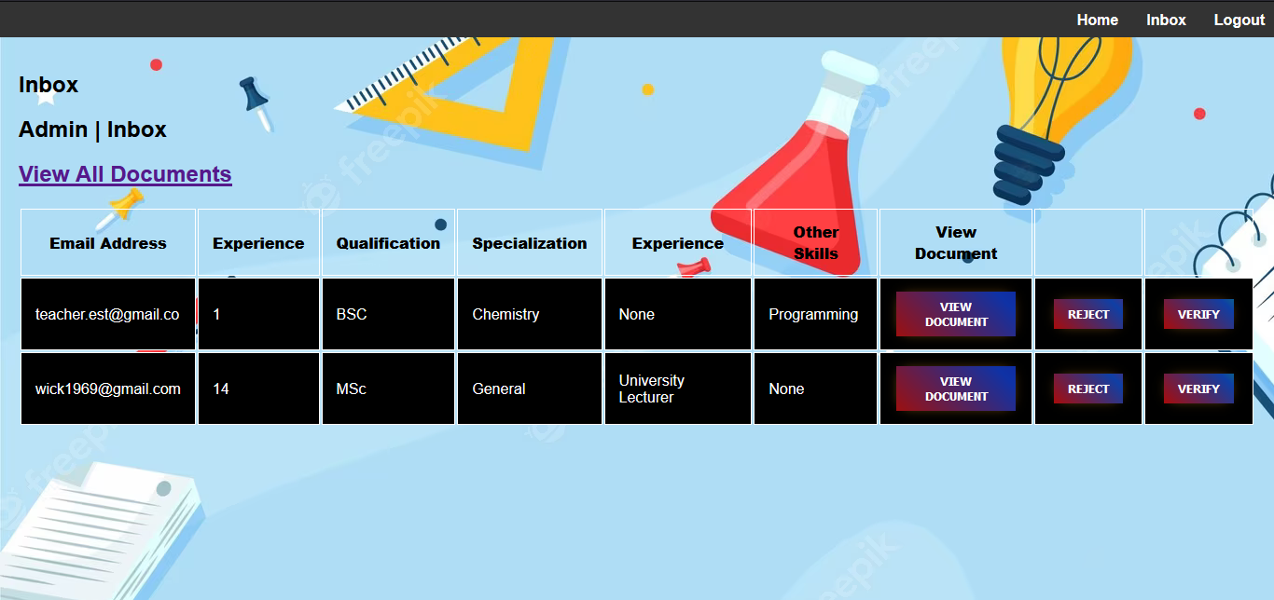

**Admin Inbox (after)**

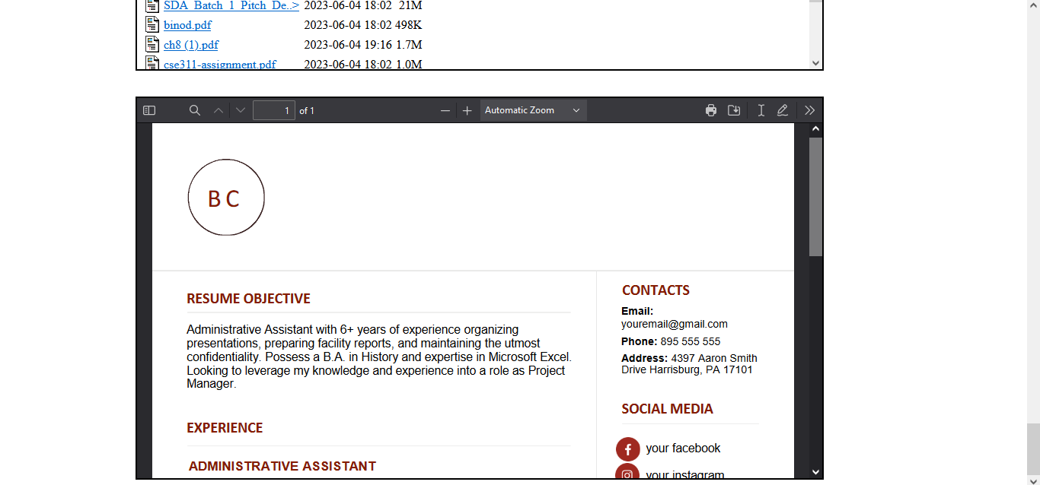

**View Document Page, for admin**



**Teacher’s Profile (post-verification)**

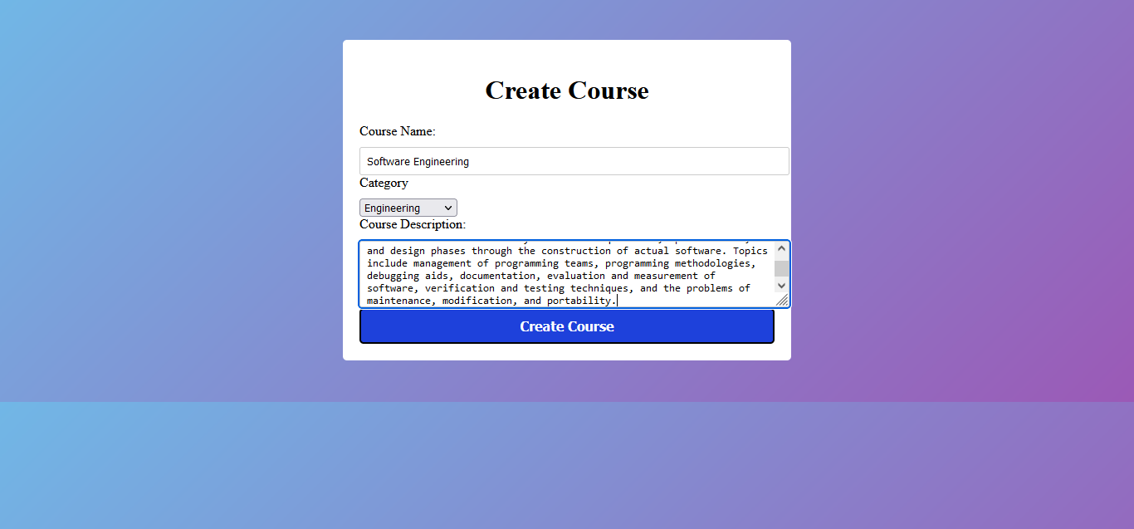

**Create Course Page**

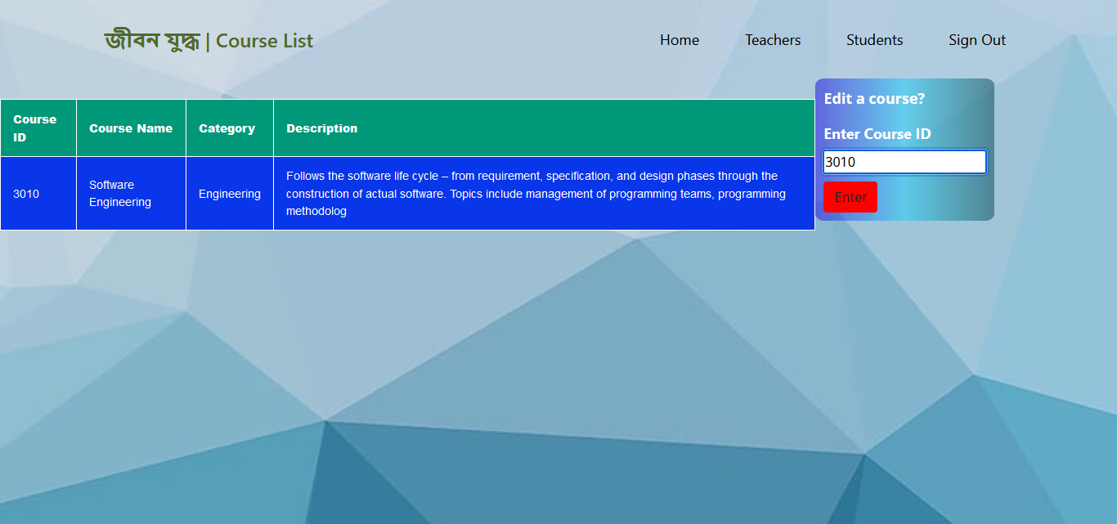

**My Courses Page, for Teacher (Before)**

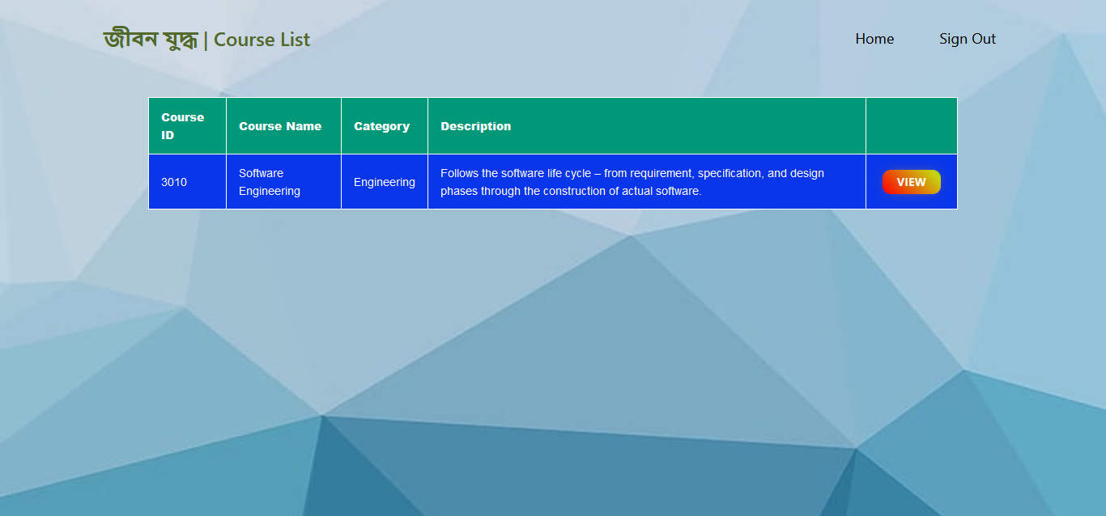

**My Courses Page, for Teacher (After)**

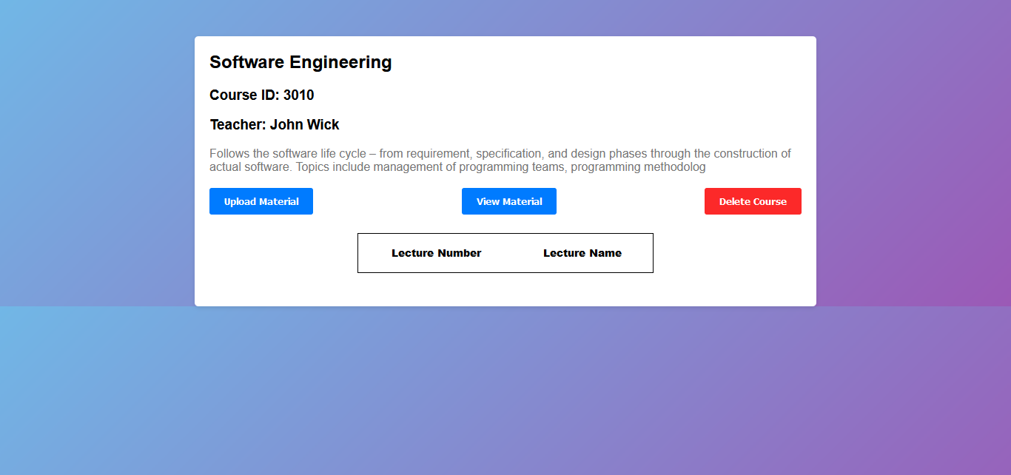

**View Course, for Teacher (Before)**

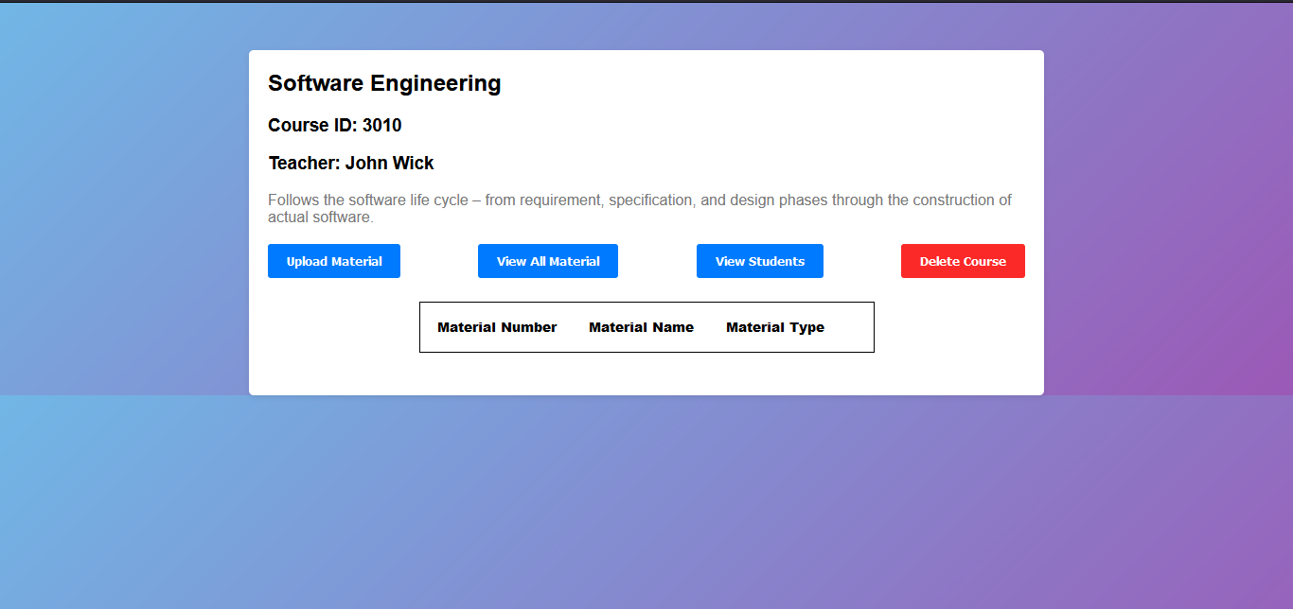

**View Course, for Teacher (After)**

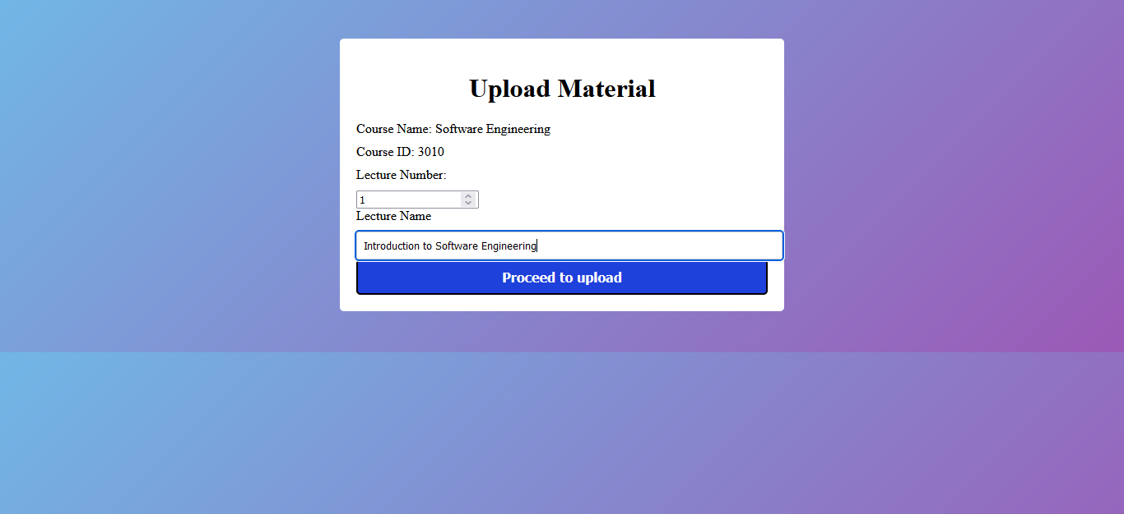

**Upload Material, for Teacher (Before)**

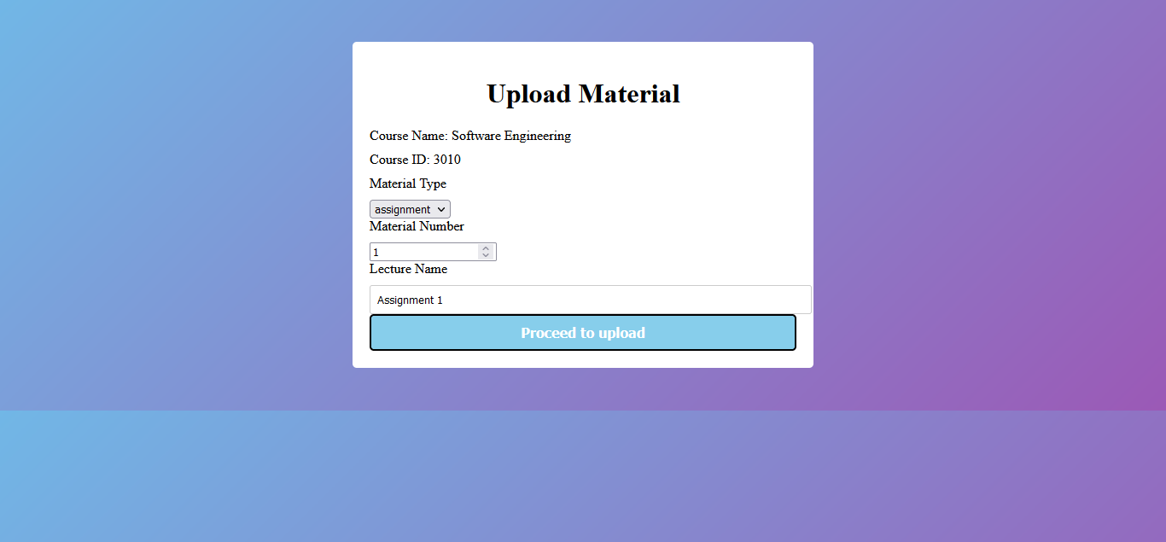

**Upload Material, for Teacher (After)**

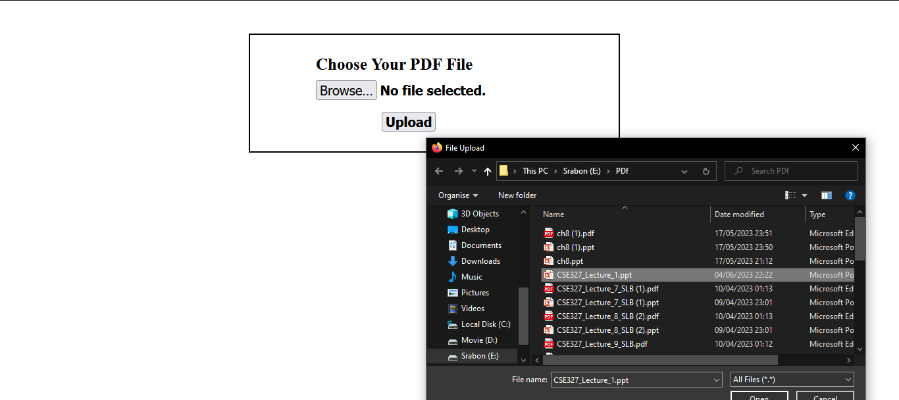

**Choose Material, for Teacher**

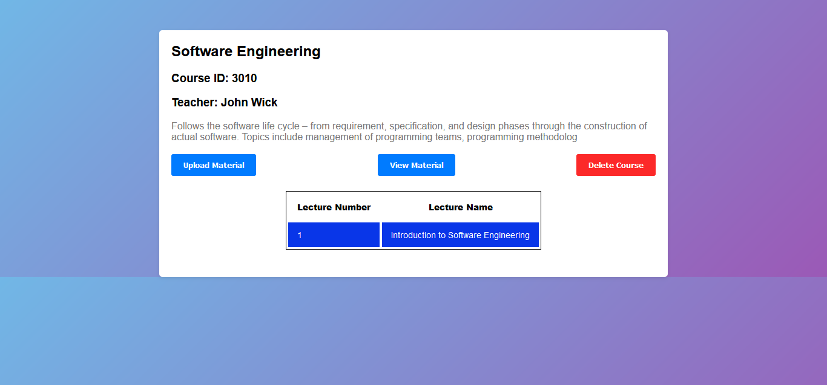

**Course Profile Page, for Teacher (Before)**

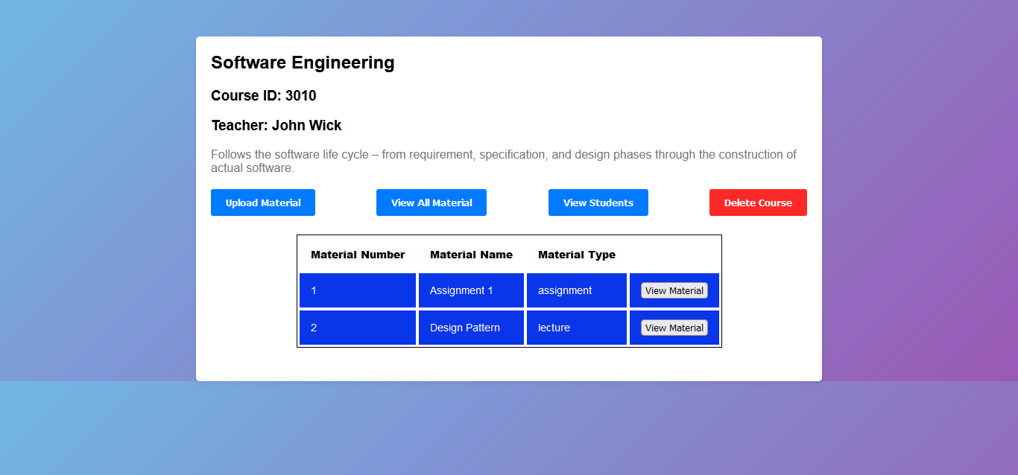

**Course Profile Page, for Teacher (After)**

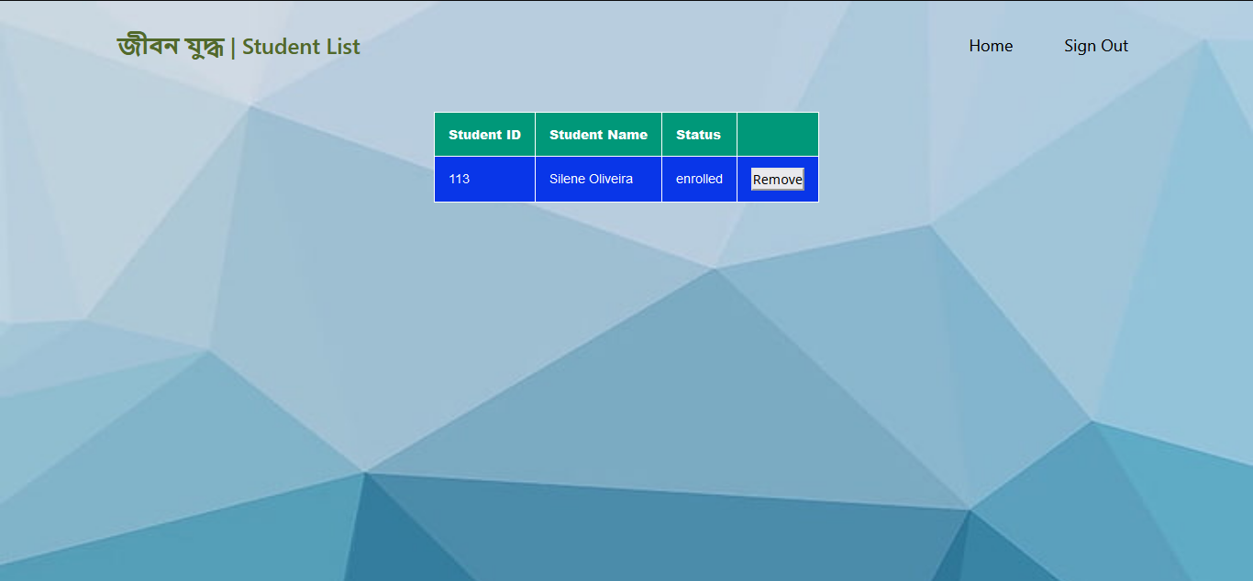

**Enrolled Student List, for Teacher (Update 3)**

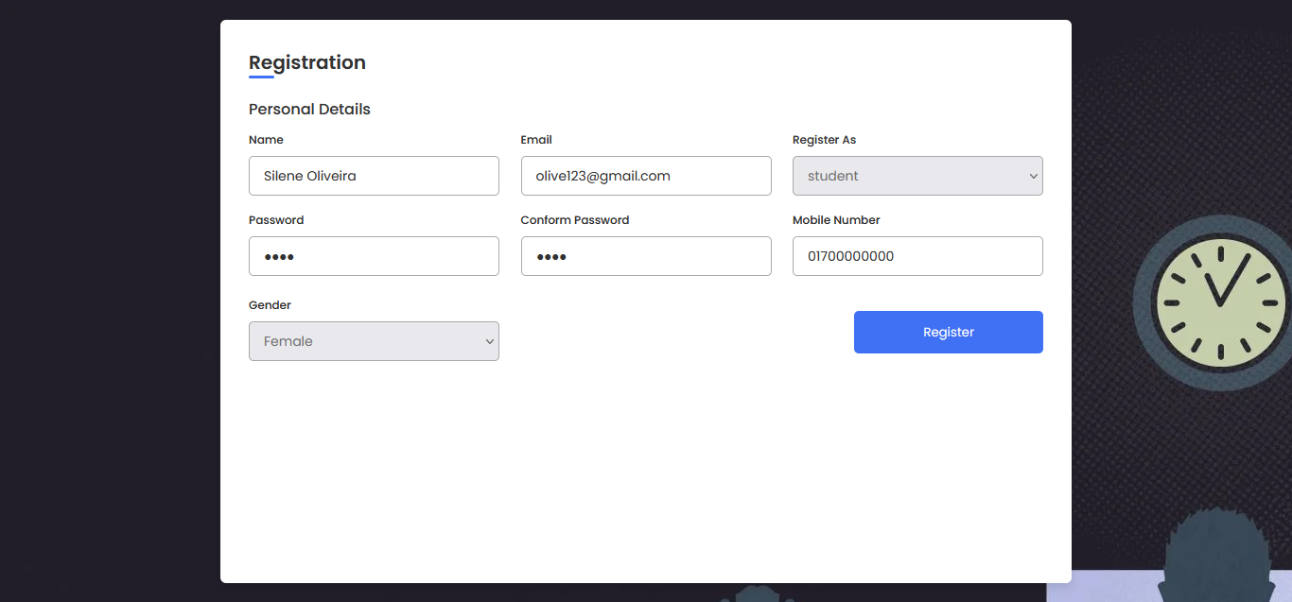

**Student Registration Page**

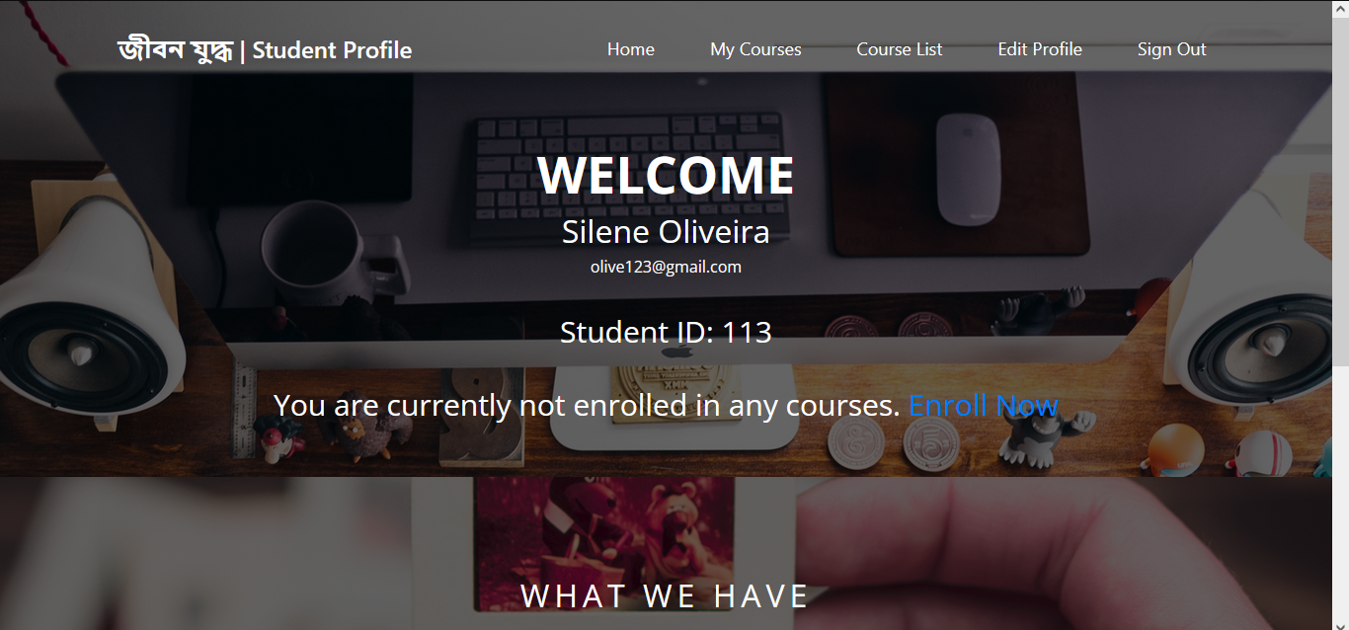



**Student Profile (not enrolled yet)**